Improving Access to Care: Moving to a Total Triage System from 30th March 2026
We know how important it is for our patients to access the care they need, when they need it. Many of you have told us that getting this care can be challenging, particularly when phone lines are busy or appointments are quickly filled.
To help address these issues, we are introducing a new approach called Total Triage — a system that is already being successfully used in many GP practices across the country. The NHS is encouraging all practices to adopt this system.


What is the Total Triage System?
The Total Triage System is a new approach to managing patient GP appointment requests at your practice, designed to ensure everyone receives the care they need in a timely, efficient, and safe manner. Instead of traditional walk-in or phone booking methods, all GP appointment requests from the 30th March will initially be assessed—”triaged”—by our clinical team before an appointment is scheduled. This process helps us to prioritise urgent cases, direct patients to the most appropriate healthcare professional, and make the best use of our resources.

Why are we introducing Total Triage?
Modern healthcare faces increasing demand and complexity. The Total Triage System aims to:
- Reduce Pressure on Our Team: Streamlining requests helps our reception and clinical staff focus on providing care rather than managing queues or callbacks.
- Improve Access: Ensure that every patient is assessed quickly and directed to the right care, reducing unnecessary wait times and ensuring urgent needs are addressed first.
- Increase Efficiency: By gathering more information up front, we can match patients with the right clinician or service more effectively, making better use of appointments.
- Enhance Patient Safety: Triaging allows us to identify critical cases sooner and ensures no urgent issues are missed.

How does the Total Triage system work?
The system is simple:
- Step 1: Submit Your Request
From 30th March 2026, all requests for doctor appointments must be submitted online via our practice website: www.parkwaymedicalgroup.nhs.uk This applies to all doctor appointment requests.
- Step 2: Tell Us What You Need
The online form will ask you for details about your symptoms, concerns, and preferences. Please provide as much relevant information as possible. This helps us assess your needs thoroughly and quickly.
- Step 3: Clinical Assessment
Our clinical team reviews each request. Based on the information you give, your request will be prioritised according to clinical need and urgency.
- Step 4: Our Response
We will contact you as soon as possible with one of the following:
Further questions if more detail is needed to ensure the right outcome
Confirmation of an appointment (in-person, phone)
Advice and guidance for self-care or pharmacy support
Referral to another service if more appropriate (e.g., mental health, physiotherapy, dietician).
All requests are dealt with on the day Monday to Friday
Benefits for patients
- Greater Convenience: Submit your request during opening hours —no waiting on hold or standing in line at reception.
- Faster Access to the Right Care: issues can be identified and actioned more quickly, while routine matters are managed efficiently.
- Personalised Service: Your information helps us direct you to the most appropriate clinician or service for your needs.
- Clearer Communication: You will receive timely updates about the progress of your request and next steps.
- Safe and Confidential: All data is handled securely and confidentially in line with NHS and GDPR regulations.

- Frequently Asked Questions (FAQs)
- What if I can’t use the internet?
If you are unable to use our website due to a disability, language barrier, or lack of internet access, please call our reception team. We will assist you over the phone.
- Who will review my request?
All requests are assessed by clinical staff, ensuring that medical decisions are made by qualified professionals.
- How soon will I hear back?
We review and respond to all requests on the same day. Urgent cases are prioritised.
- Is my data safe?
Absolutely. All information you provide is stored securely and only accessed by authorised staff for your care.
- Can I still see my usual GP?
Whenever possible, we will honour requests to see a specific clinician. However, urgent cases may be seen by the first available suitable professional.
- How to Submit a Request
Visit www.parkwaymedicalgroup.nhs.uk and click on the Contact Us Online on our home page
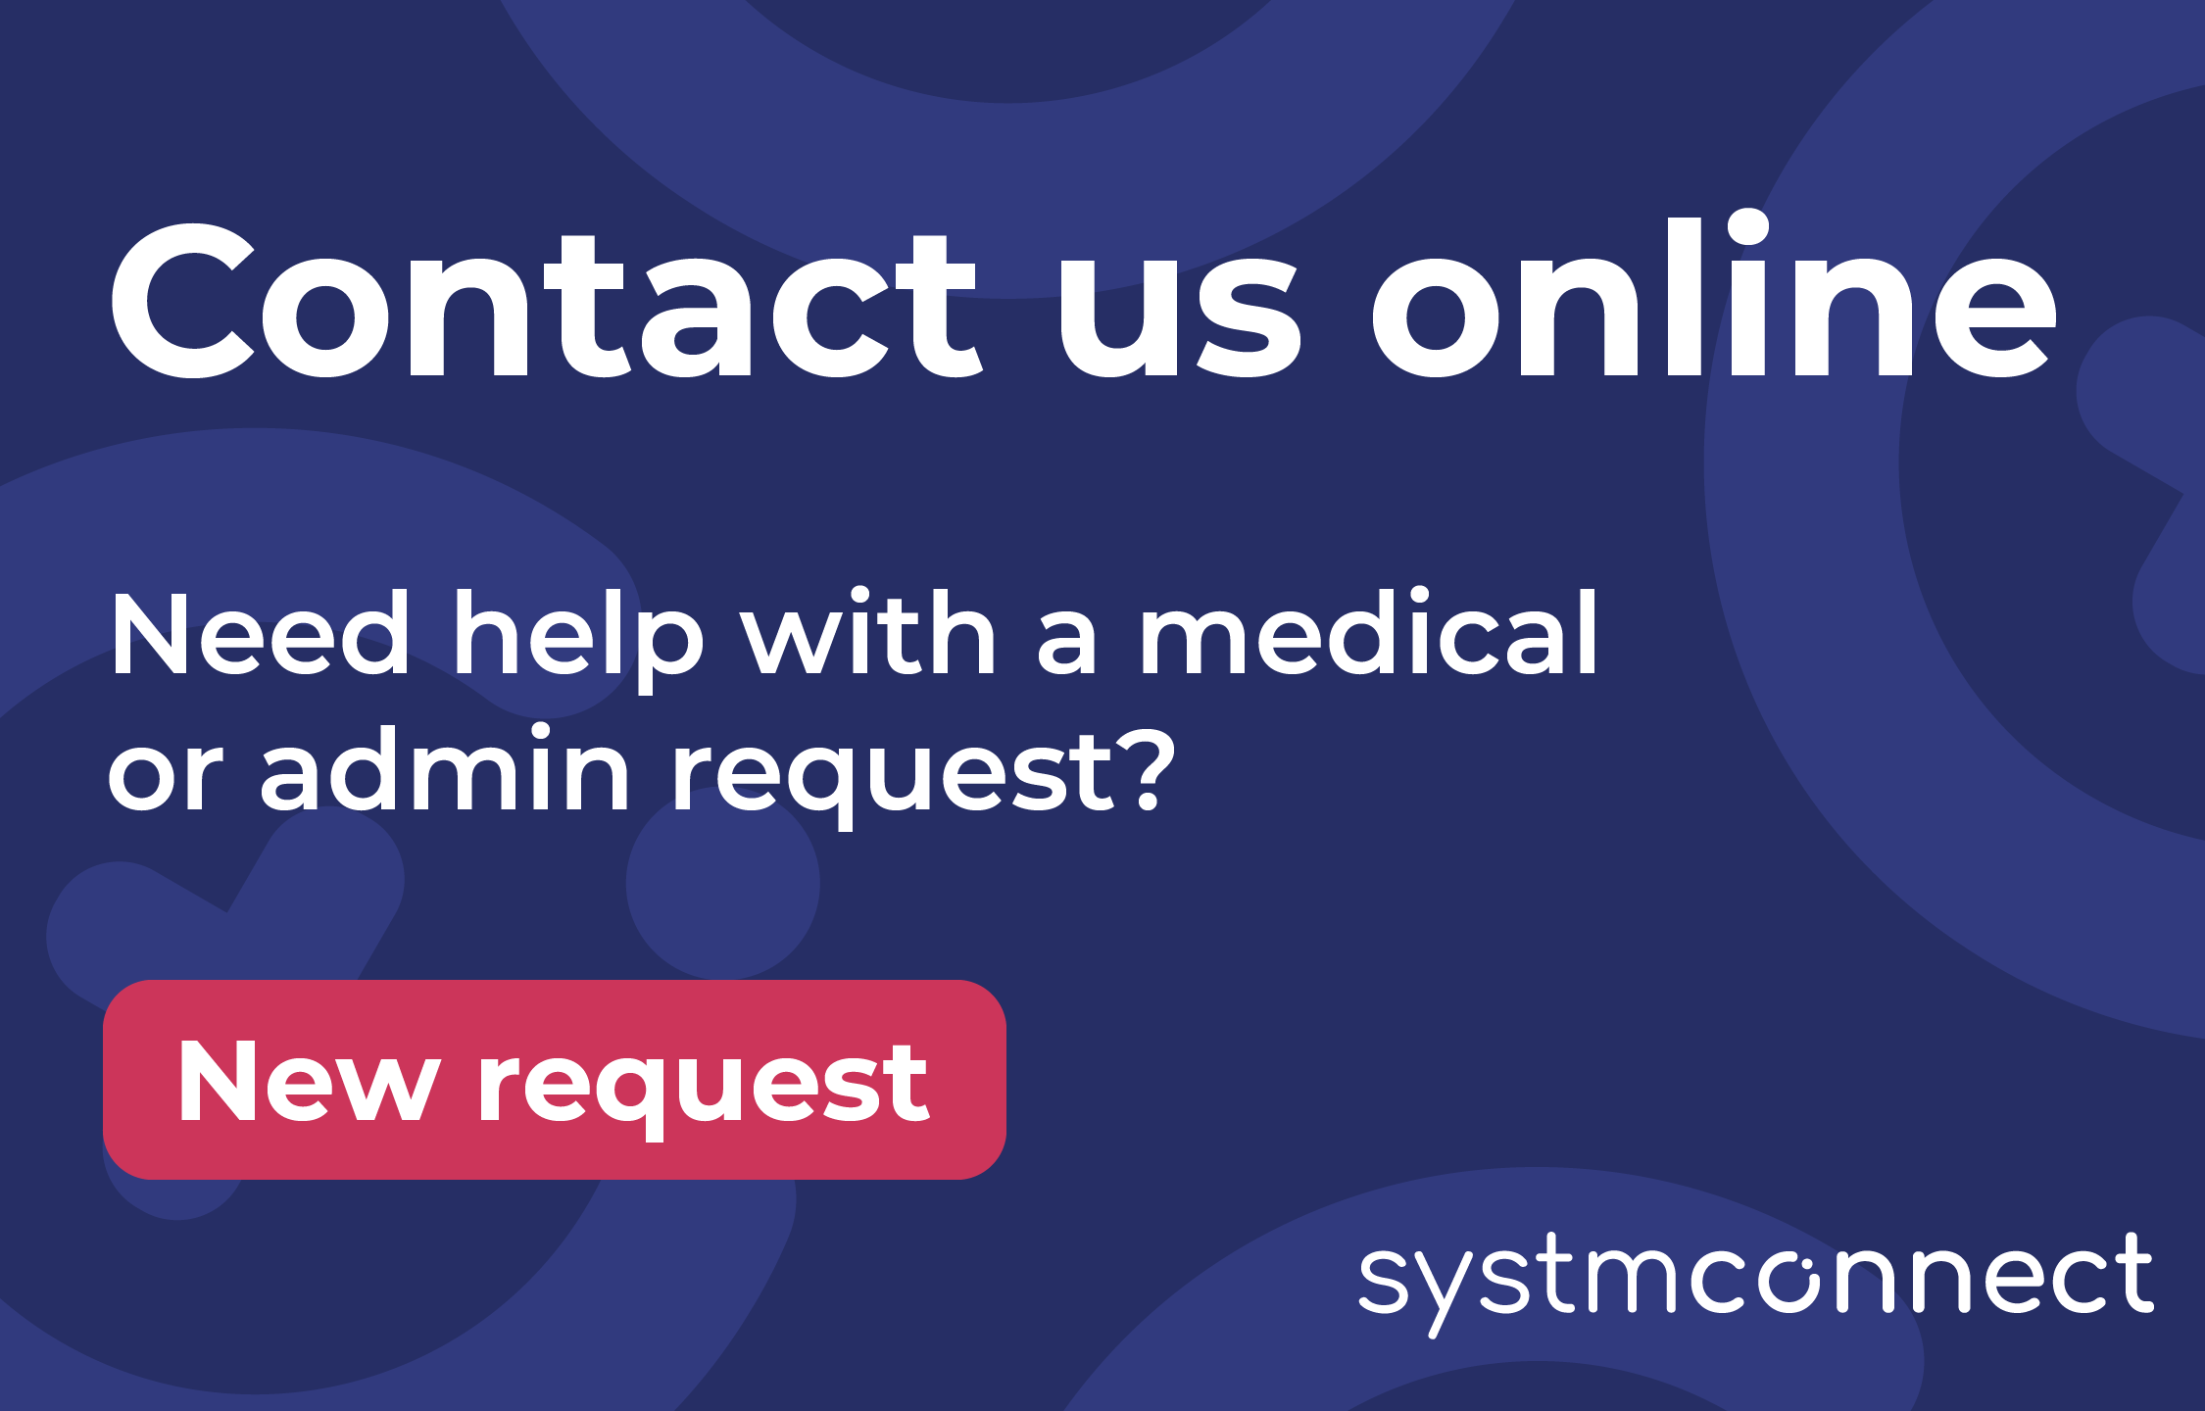
- Fill in the online form with as much detail as possible.
- Submit your request and wait for our team to contact you.
- If you need urgent help outside of practice hours, please contact NHS 111 or, in an emergency, call 999.
Tips for using the Total Triage system
- Be Detailed: More information helps us help you faster and more accurately.
- Check Your Contact Information: Make sure your phone number and email are up to date so we can reach you.
- Monitor Your Messages: We may ask for additional information or provide instructions via text, email, or phone.

Feedback and support
- Feedback and Improving the System
- We are committed to making the Total Triage System as effective and patient-friendly as possible. Your feedback is valuable—please let us know about your experience, good or bad, to help us improve.
Further Support
- If you have any questions or concerns about the Total Triage System, please contact our reception team for help. We are here to support you and ensure you get the care you need, when you need it.

- We are offering drop in sessions to support our patients on using the SystmConnect form, please keep an eye out for up and coming dates

